11.68:
(a)

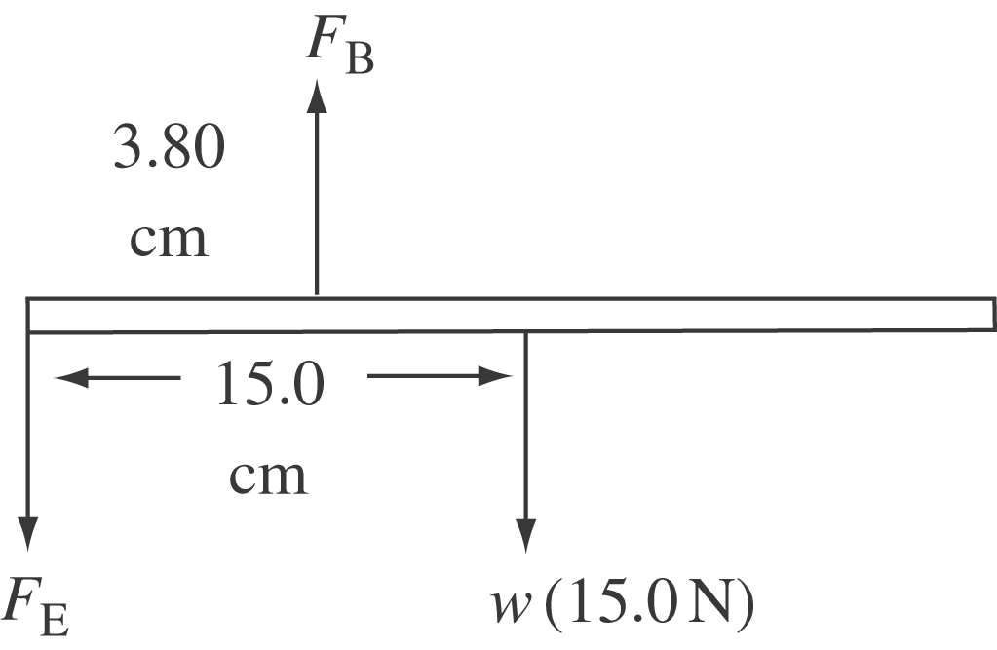

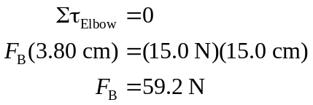

(b)

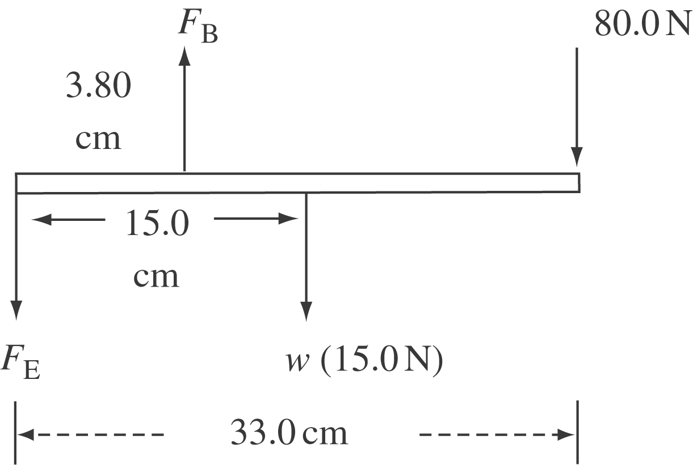

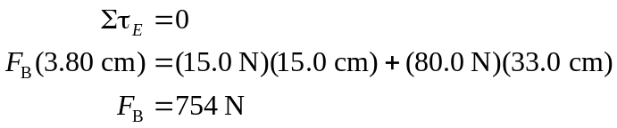

The biceps force has a short lever arm, so it must be large to balance the torques.
(c)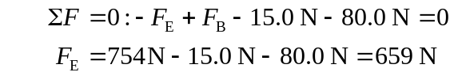
(d) The biceps muscle acts perpendicular to the forearm, so its lever arm stays the same, but those of the other two forces decrease as the arm is raised. Therefore the tension in the biceps muscle decreases.

